Dynamic Invoice Paginated Report

Stepwise implementation of Dynamic Invoice using Power BI Report Builder
Step 1: Open the power BI report builder application and click on “New Report”.
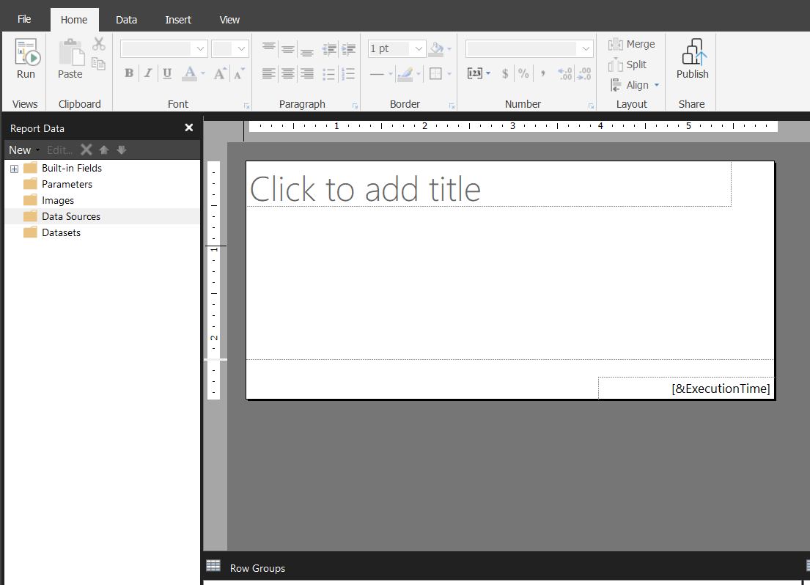

Step 2: Add the Data Source and get the data from data source. Right click on Data Sources Tab you’ll get 3 options.
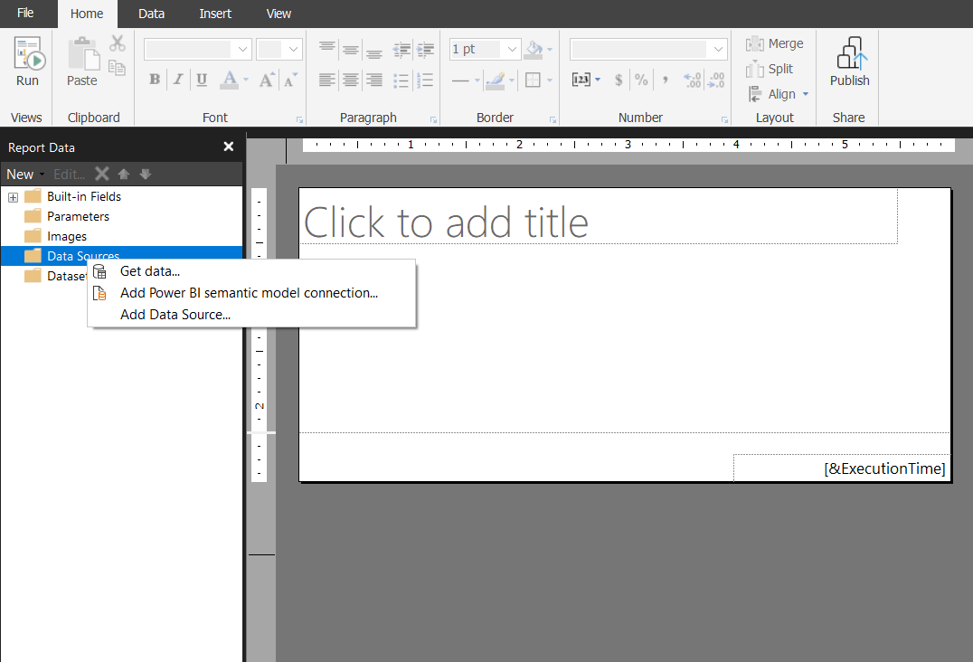

In my case I have take the data from Power BI semantic model which is already available in Power BI services. Therefore, click on “Add Power BI semantic model connection”.

Step 3: Select your workspace and semantic model. Click on “Select”.
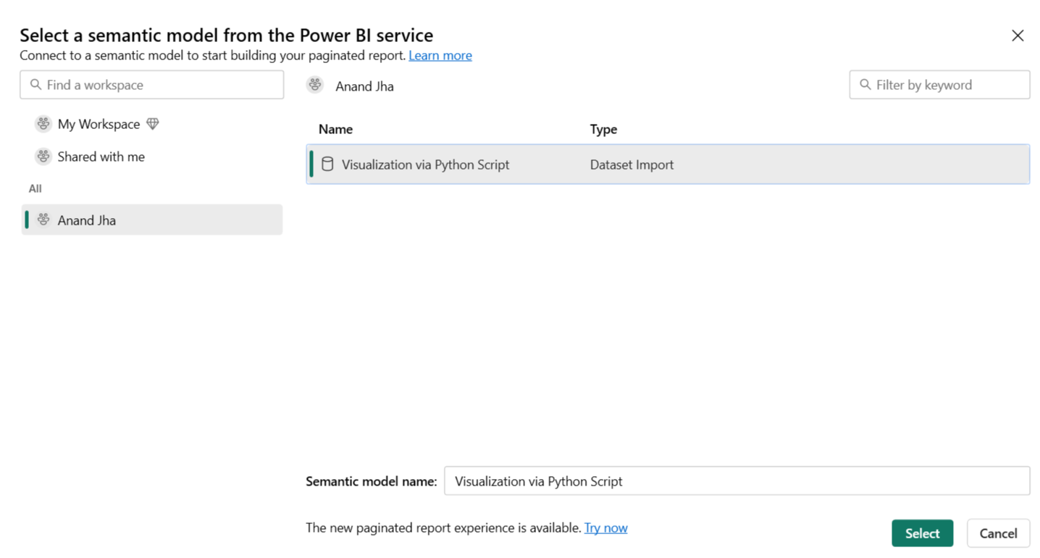

Now, you can see the data source is present under Data Source Tab on the left Pane.

Step 4: Right click on the “Datasets” tab just below the Data Source. Click on “Add Dataset”.
Give a name to your dataset and select the data source from the dropdown.
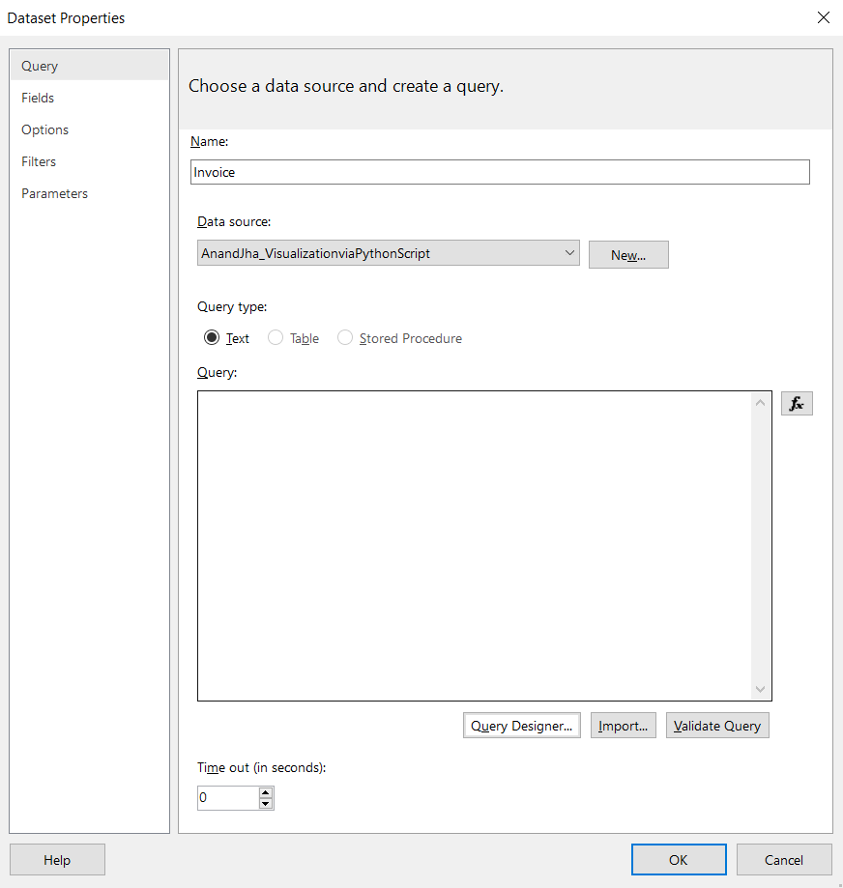
Click on Query Designer button.

Step 5: Expand the table on the left of query designer. Choose the columns that are necessary to create the invoice and drop in the blank area.
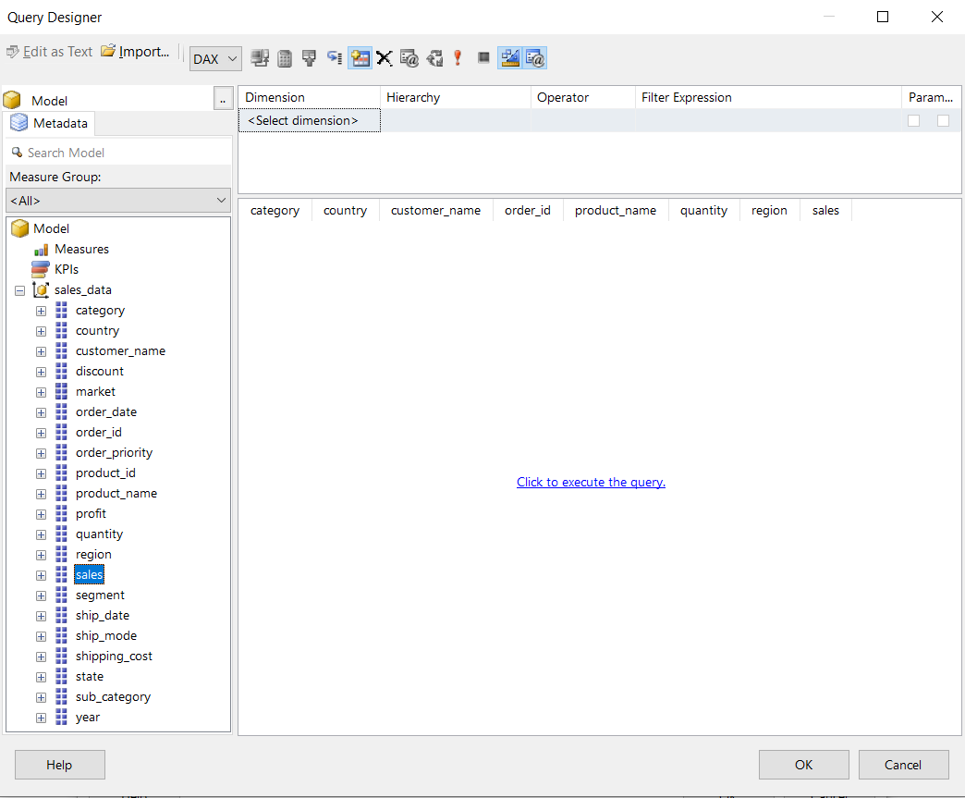
Click on “Click to execute the query”.

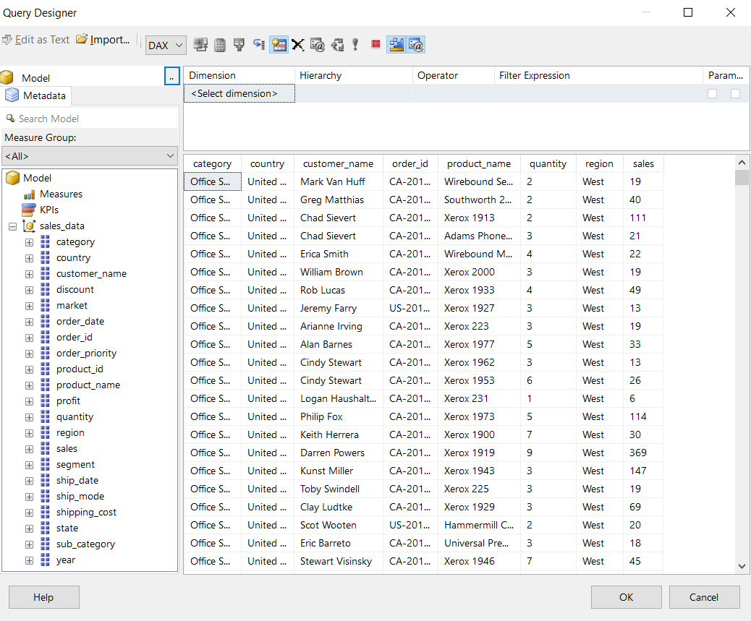
Click on “OK” and again click on “OK” in Dataset Properties box.

Step 6: Now come to invoice page customization.
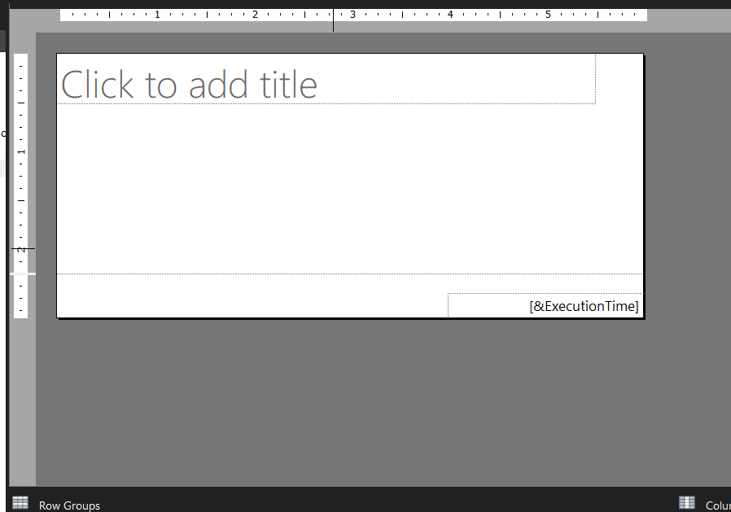
Remove the text box and execution time in the footer and add a header from the Insert Tab present the menu ribbon.
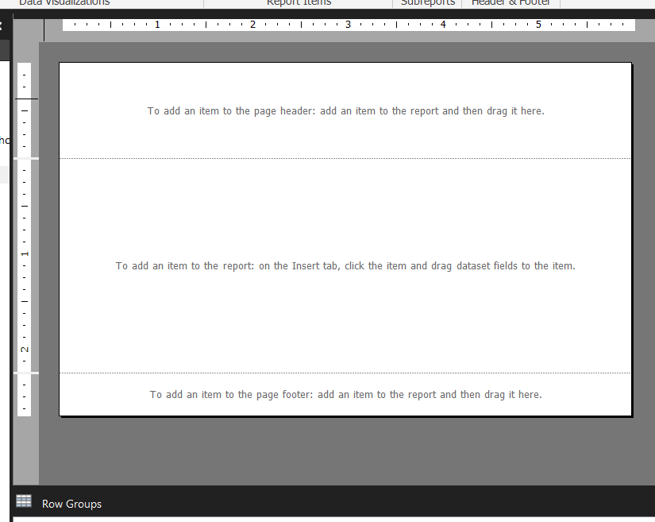
Step 7: Add a logo image on the header. Double click on the Image Icon and click on Import in the Image Properties box. Select the logo and click on OK.
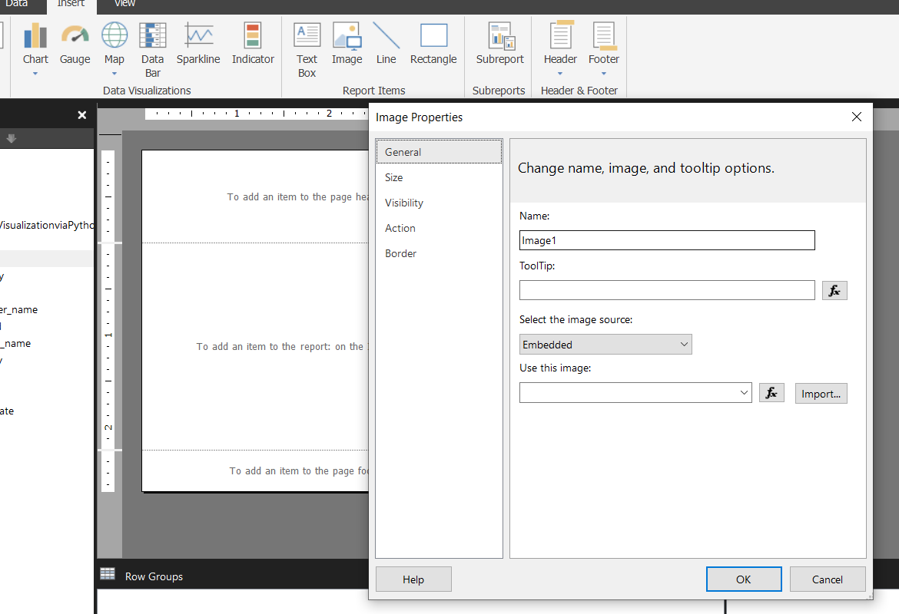

Step 8: Add a text box for showing the Invoice no. and date.
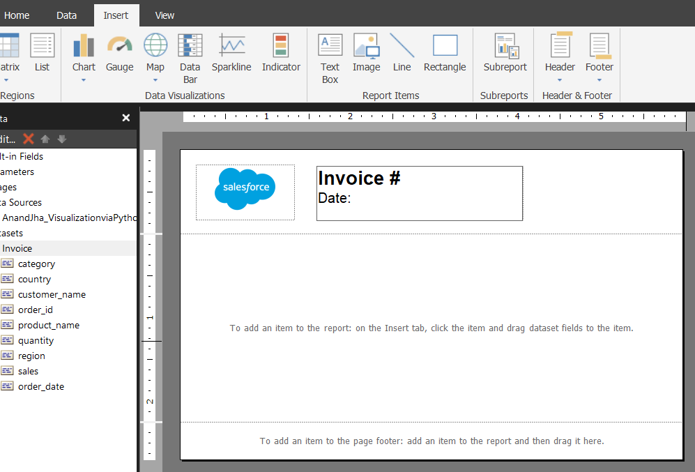
Now, add ”Order ID” column after the Invoice and “Order Date” after the Date by drag and drop.
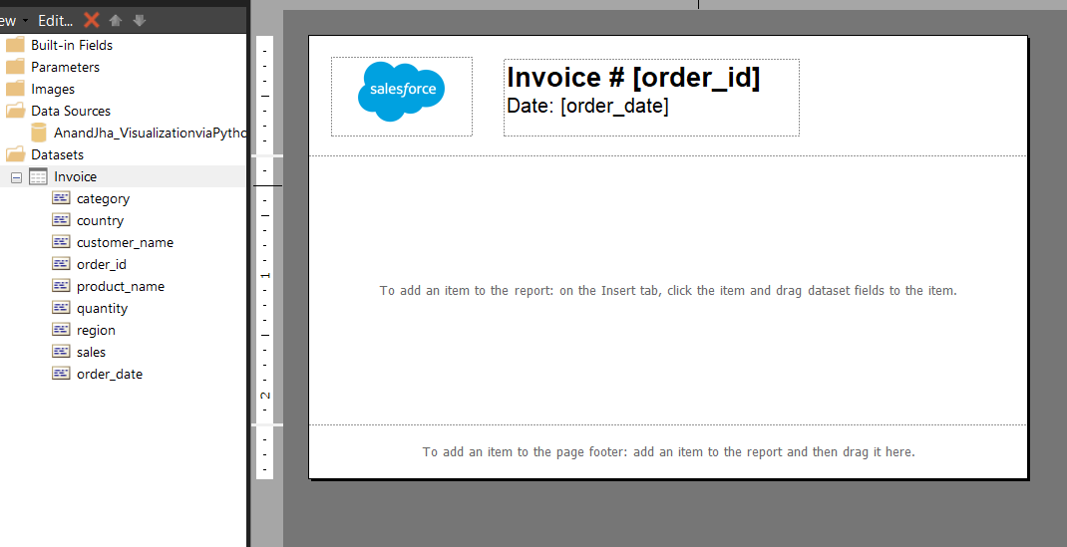
Summarize the Order ID and Order date by First value. To do that select the placeholder and right click on it.

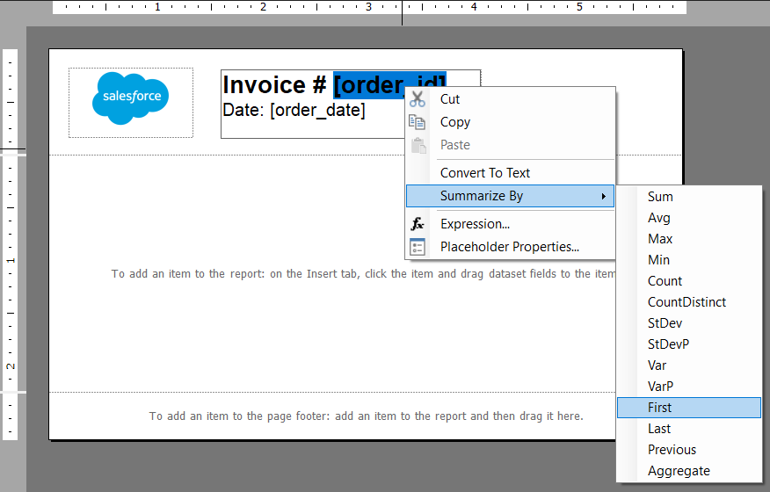

Now we have to specify the columns are coming from which dataset. To do that right click on the placeholder and click on Expressions.

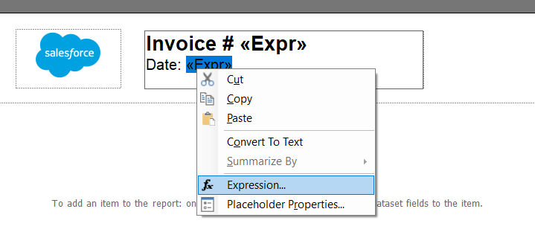
Now change the expression from =First(Fields!order_date.Value) to =First(Fields!order_date.Value, "Invoice"). Do the same for both placeholders.
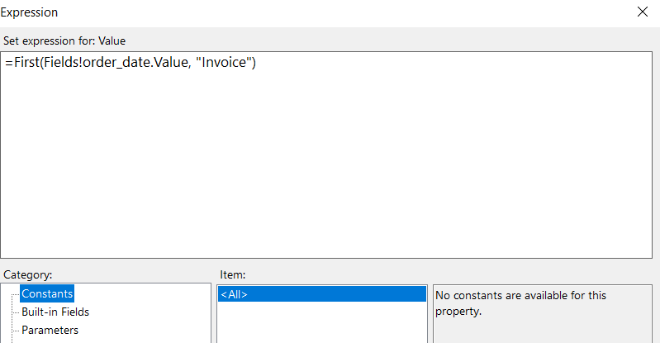

Step 9: Expand the header and add two text boxes in order to add “From” segment and “To” segment. “To” section should be dynamic, therefore we have drag and drop the column names that are necessary to show for whom the invoice is being generated.
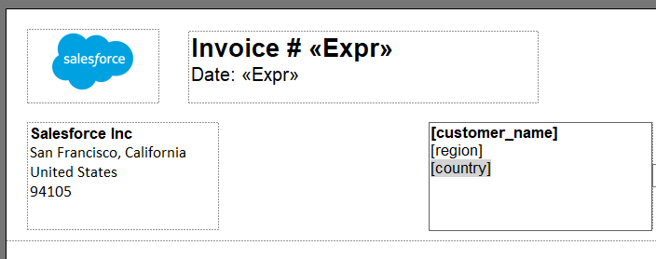

Do the same as we did for ‘order_date’ and ‘invoice’ placeholder by summarizing to first and changing the expression to tell where the data is coming from.
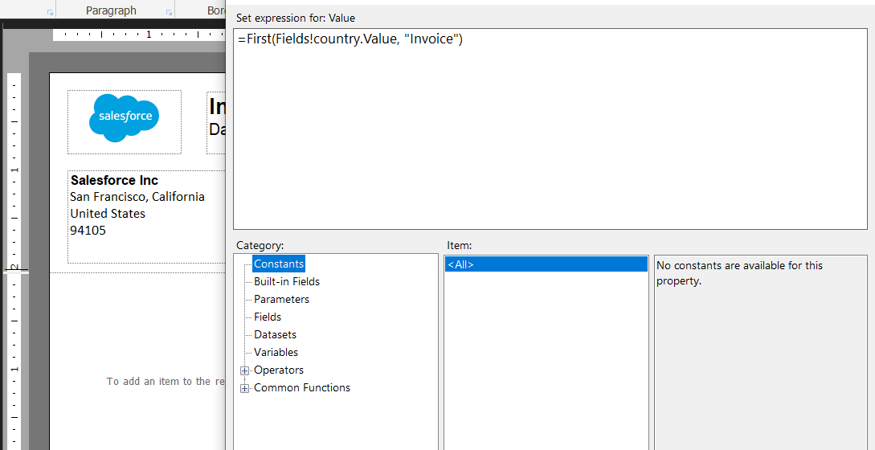

Step 10: Customize the footer, add a text box and add the required text that are used in an invoice.
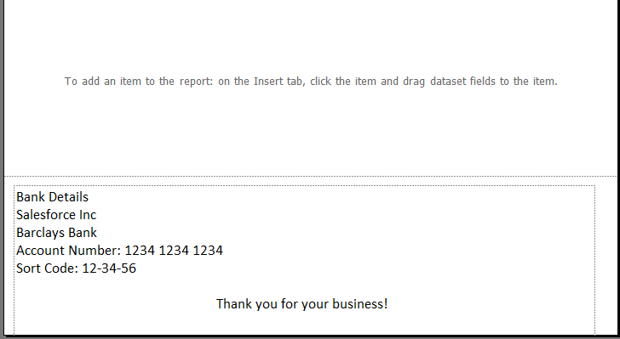

Step 11: Add a table to the report. Go to Insert, Click on Table and choose Table Wizard.
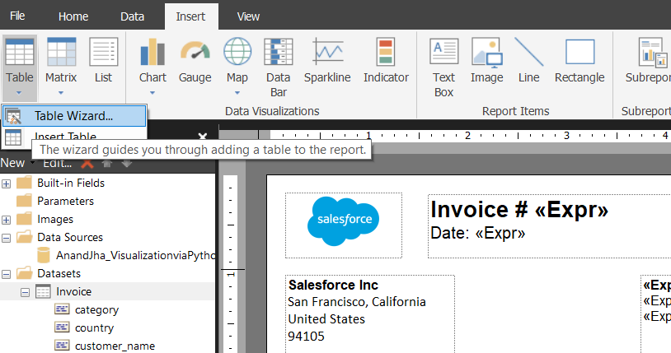

Now select the dataset from the box which has appear and click Next.
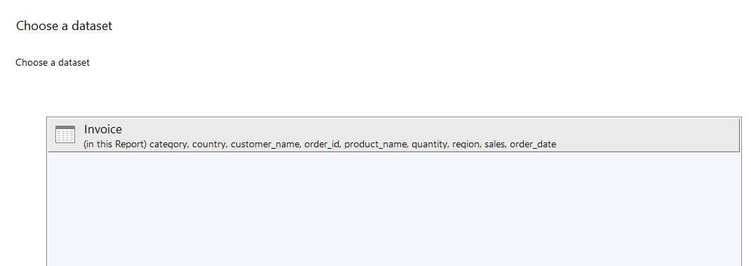

On clicking next you will see a “New Table or Matrix” box. Choose by dragging and dropping the columns as shown in the image below. Don’t forget to summarize the quantitative columns by sum.
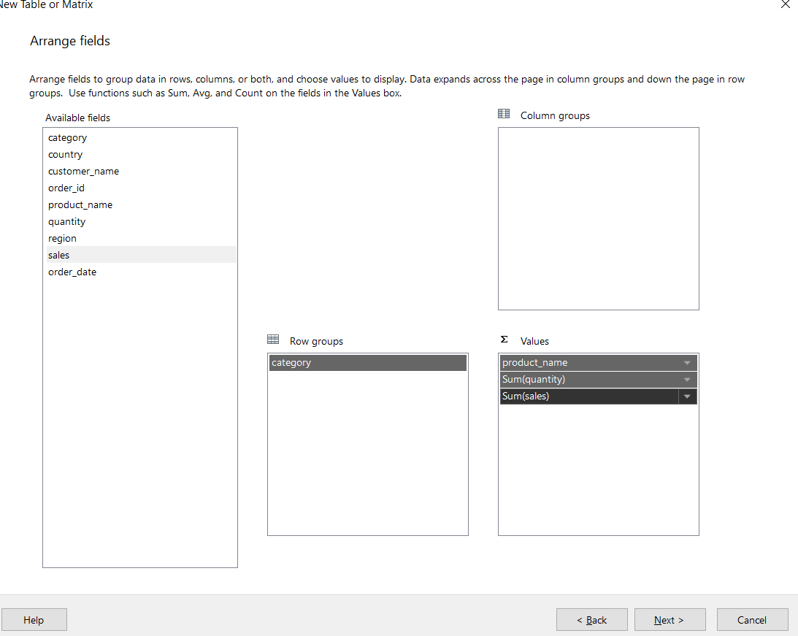

Click Next and Uncheck the “Expand/Collapse groups”
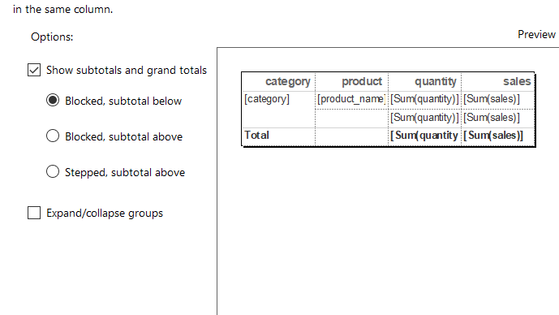
Click Next and then “Finish”, result will look like this.
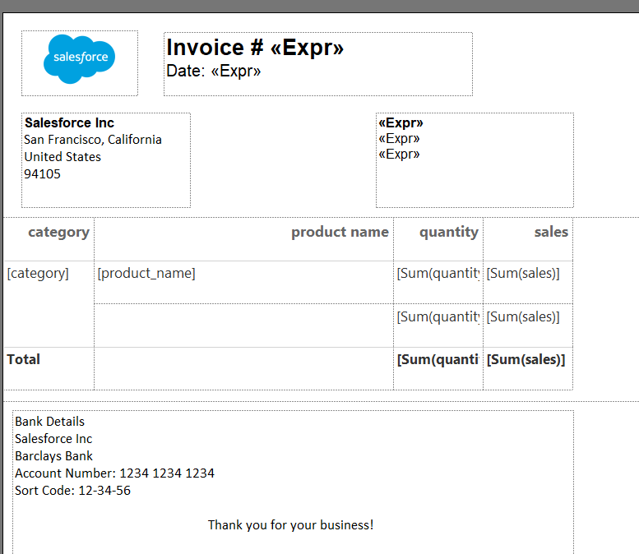
Format the Sales by using “,” separator and currency sign. To do that right click on placeholder and click on Placeholder properties. Go to Number -> Currency , and edit accordingly as given the image below. Repeat for all the sales placeholder.
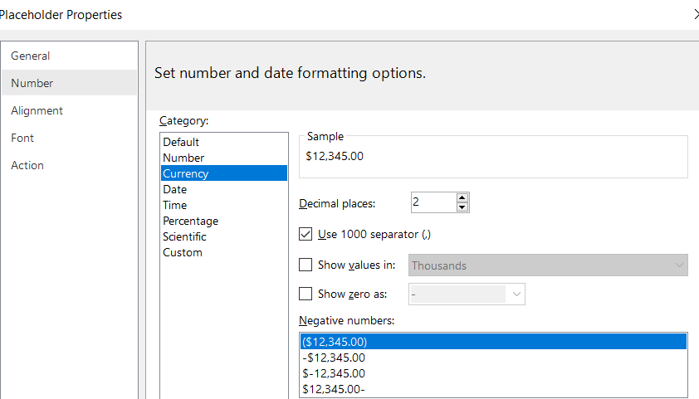

Step 12: Add a Parameter to show the invoice only for the selected customer name.
Add another dataset “Customer” and choose two columns that are OrderID and Customer Name.
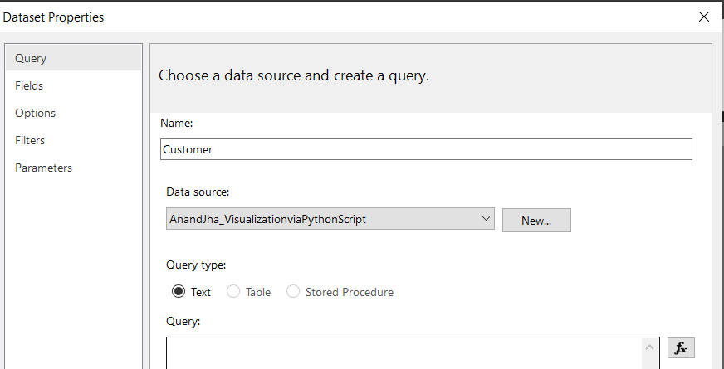

Add a parameter, Right Click on Parameter in the left pane and Click add parameter. Give a name and a prompt.
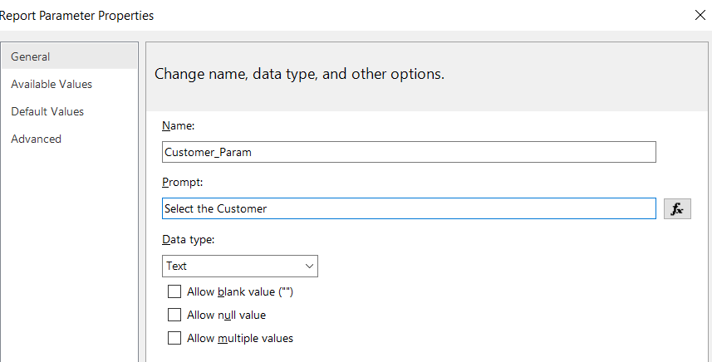
Click on the “Available values” and choose “ Get Values from a query”. Select the dataset we create recently which is “Customer” and choose value field as “OrderID” and Label as “Customer Name”.
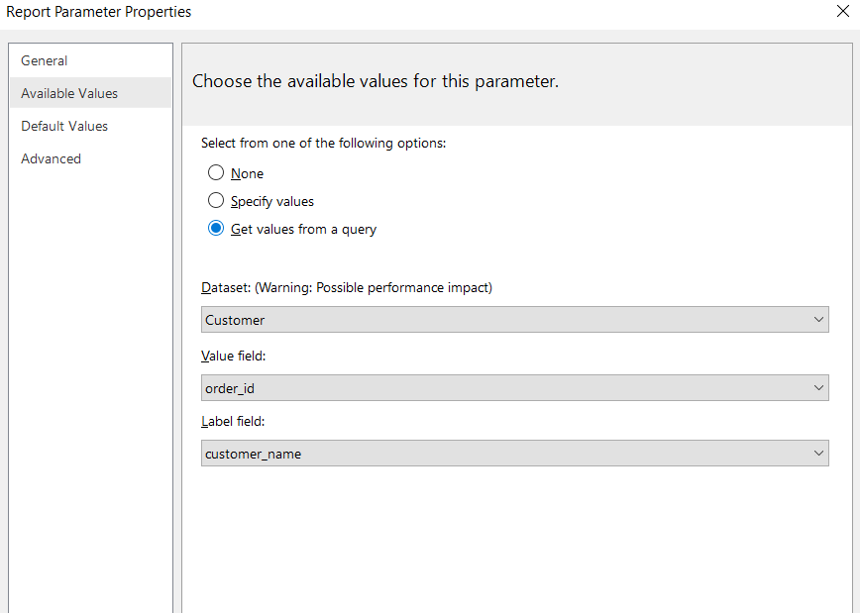
Step 13: Link the Parameter to the “Invoice” dataset as all the data coming from Invoice table.
Right Click on Invoice and click on “Dataset Properties”. Then go to “Filters” and click on “Add”.
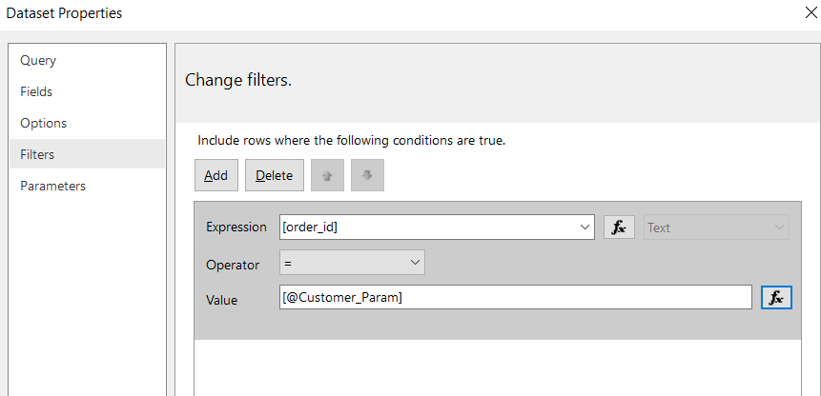
Choose “order_id” from the dropdown in expression and for the Value click on formula button.
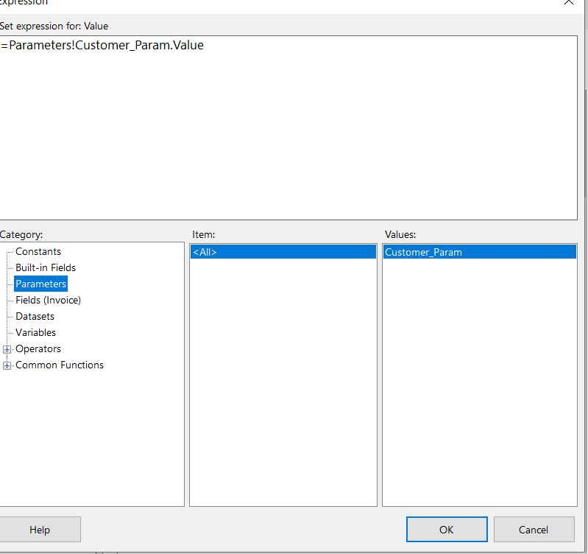
Select parameters and doule click on value “Customer_param” so that the expression appears in above box. Click OK.

Go to Home. Click on Run
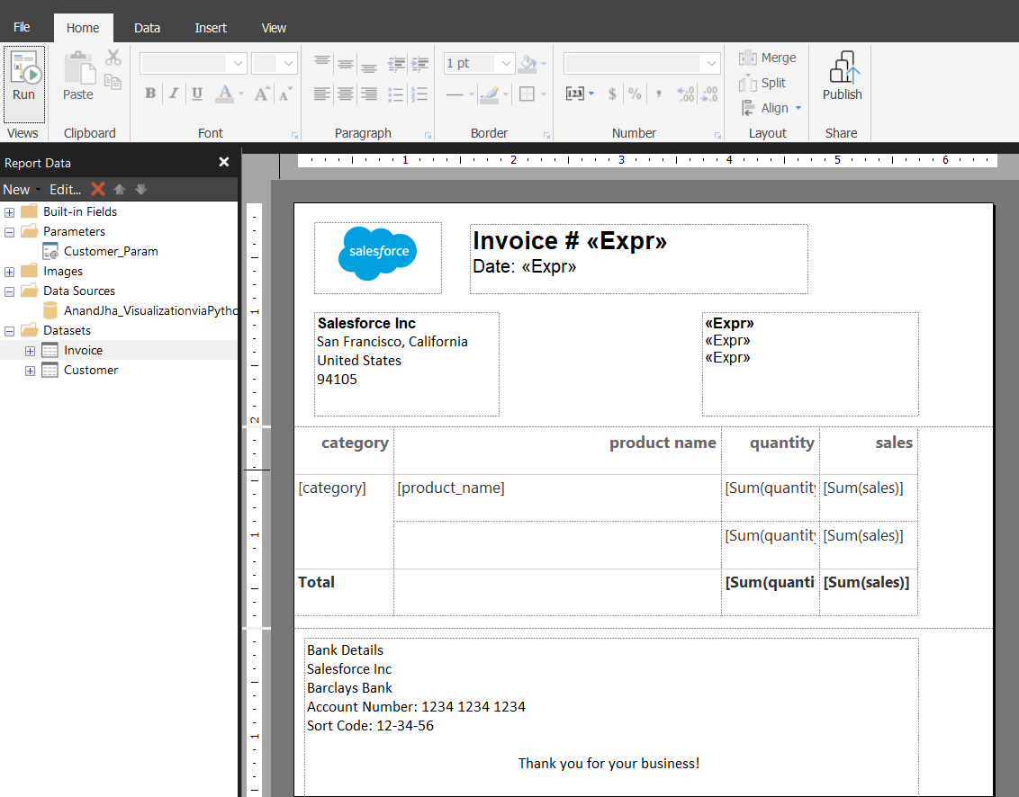
This is the final output.

